Logistic Application Assignment

1. Create an application into Salesforce name Logistic Application
2. Create object name as:

* Customer Information
* Assert and driver
* Quote Management
* Invoice
* Status

1. Customer location and management:

* Address
* City
* Postal code
* Province
* Street
* Name
* Quantity
* Product
* Email
* Updating record of unit price based on product chosen:

Mobile: -45K

Watch: -90k

Based on Your Choice.

Visual force page for Invoice Generation: -

**Code: -**

<apex:page renderAs="pdf" standardController="Invoice__c">

<div style="background-color:gray;">

<h1>

<center style = "font-size:25px;">

ABC Limited. <br/><br/>

INVOICE

</center>

</h1> <br/><br/>

</div>

<apex:pageBlock >

<apex:pageBlockSection >

<apex:outputText value="{!Invoice__c.Name__c}">

</apex:outputText><br/><br/><br/>

<apex:outputText value="{!Invoice__c.Address__c}">

</apex:outputText><br/><br/><br/>

<apex:outputText value="{!Invoice__c.Street__c}">

</apex:outputText><br/><br/><br/>

<apex:outputText value="{!Invoice__c.City__c}">

</apex:outputText><br/><br/><br/>

<apex:outputText value="{!Invoice__c.Postal_Code__c}">

</apex:outputText><br/><br/><br/>

<apex:outputText value="{!Invoice__c.Sub_Total__c}">

</apex:outputText><br/><br/><br/>

</apex:pageBlockSection>

</apex:pageBlock>

</apex:page>

Report Page: -

Name: - Customer Information Report

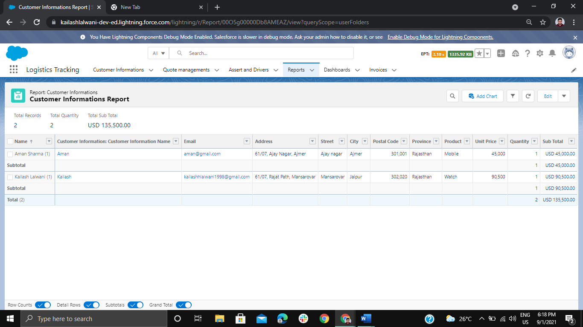

Dashboard Page: -

Name: - Customer Information

